Let’s Play Safe

By Jill Nyland

My name is Jill. I like to ride my bike outside.

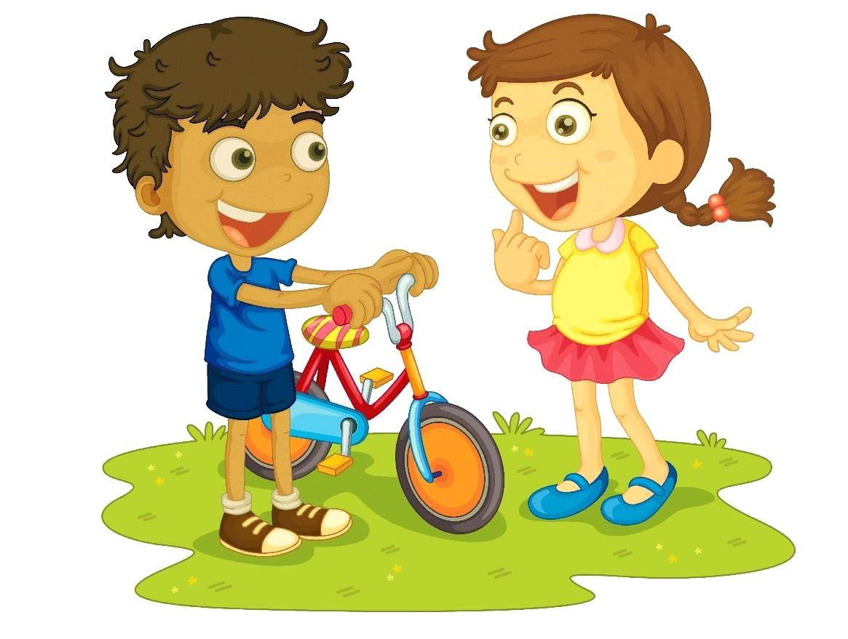

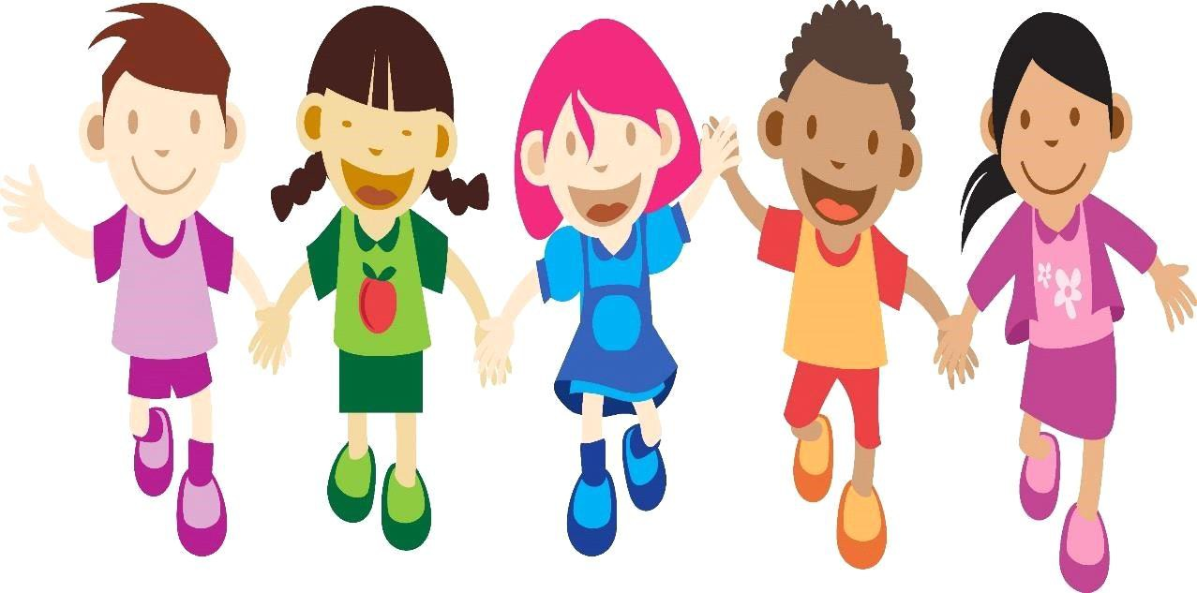

I have a brother and lots of friends. We like to play out outside
together.

My friends and brother like to go swimming when it is hot outside. I like summer. We all like to splash one another in the pool.

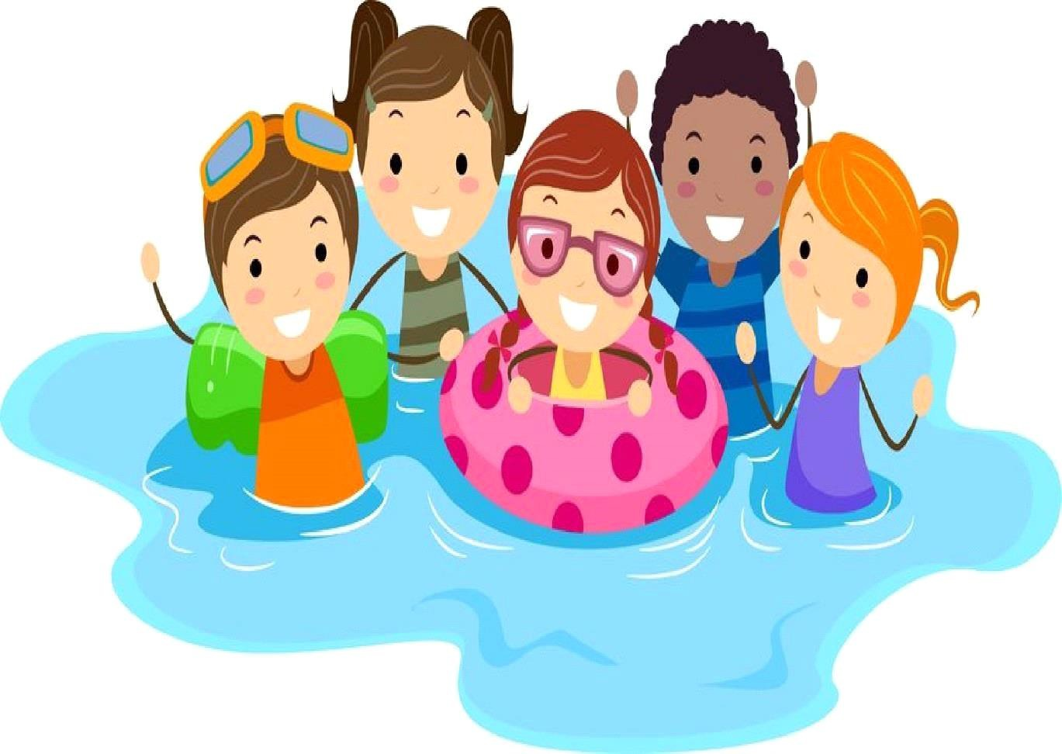

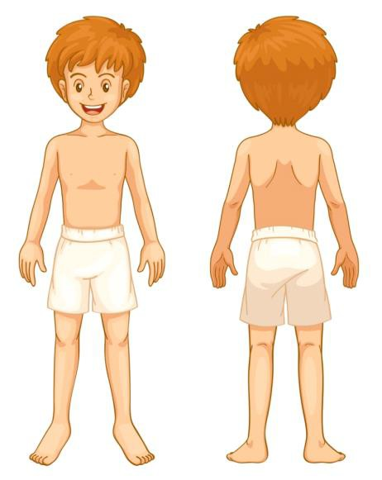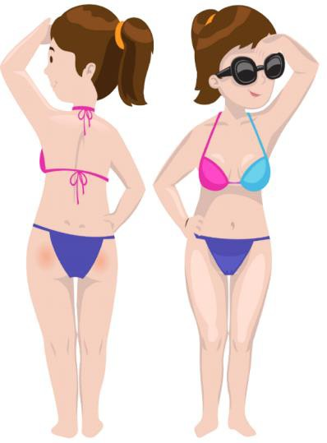

When we go swimming, we wear swimsuits. My mom and dad told me that we need to be safe and not let anyone touch us on our private parts. Our private parts are under our swimsuits in the front and the back. Our private parts are also under our swimsuits on our chest. No one should ever touch us on our private parts. Our private parts belong to us only.

If anyone ever touches us on our private parts, we need to be safe and tell someone we know. We can tell our teachers, a police officer, or our mom and dad.
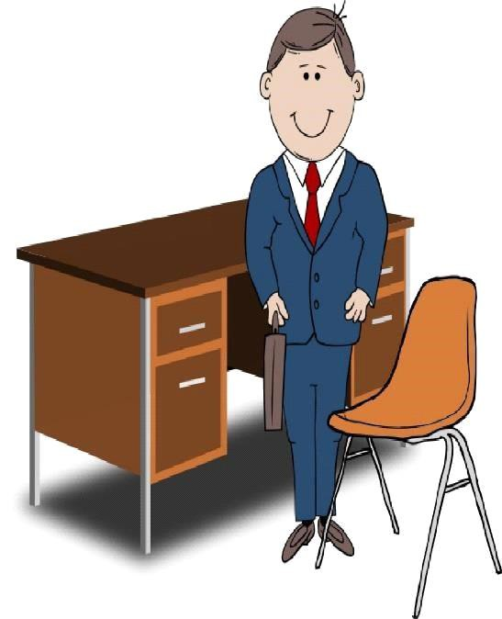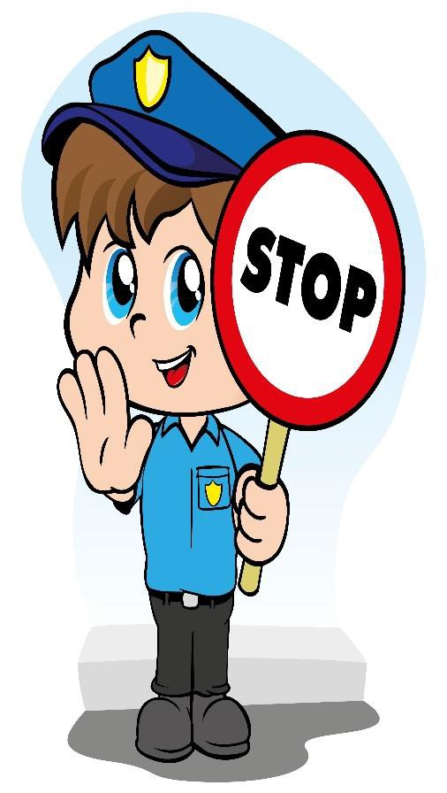

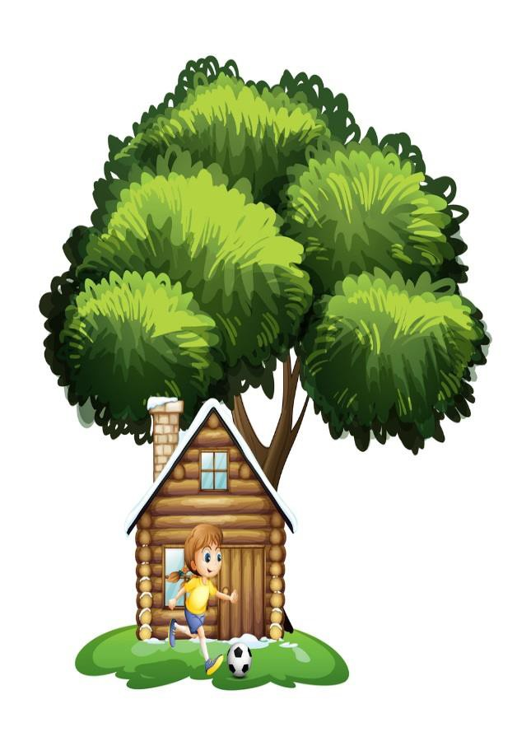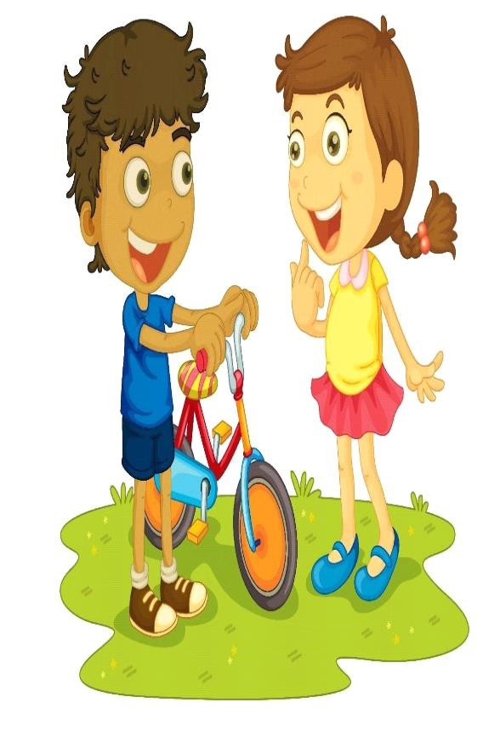
When my friends come over and we go somewhere else to play, I sometimes forget to tell my mom and dad where I am going. We should always let our parents know where we are going. We can use the computer to send a message to our parents.

Computers are fun. We are learning from computers and books at school. With a computer we can send messages to our friends. We can also look at photos of our friends, family and animals.

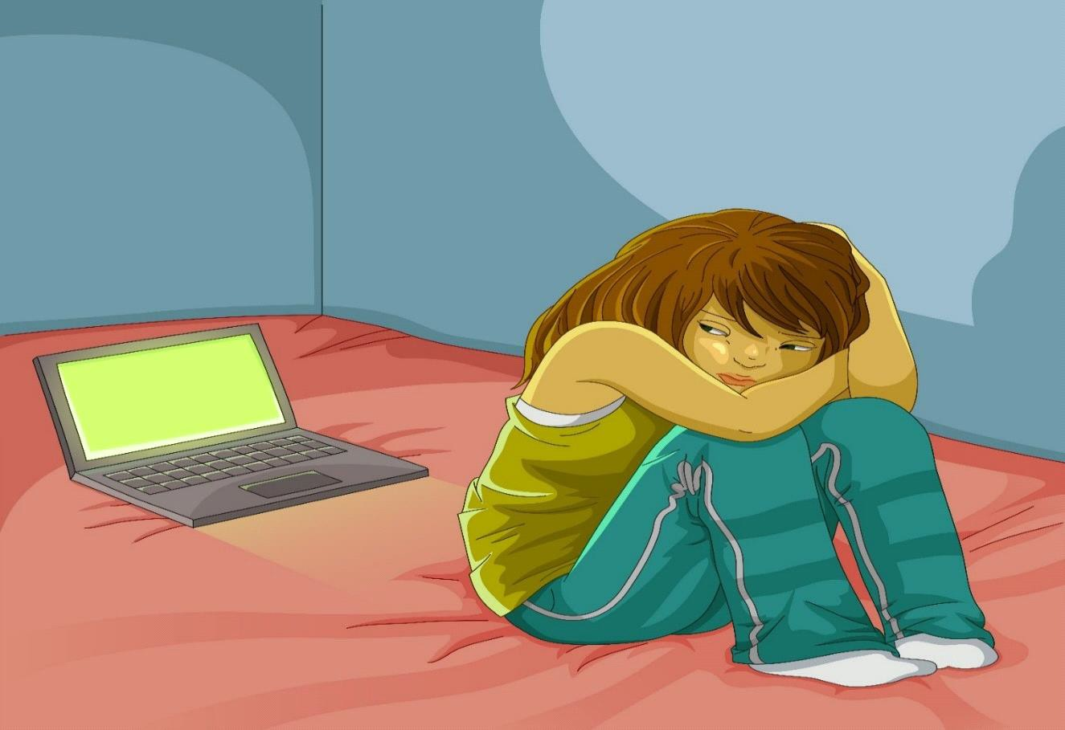

My friend Sarah likes to use the computer to send messages to her Internet friends. She told me that someone on the Internet said she was ugly and called her a bunch of mean names. This hurt her feelings. This is called bullying and it is wrong. If anyone is ever mean to us on the computer, we need to tell. We can tell our teachers, parents, or a trusted friend.

To be safe on the computer, we should never give our full name, address, phone number, or password to anyone. We should never meet with Internet friends without asking a trusted adult first. A trusted adult can be our parents, teachers, or police officers.

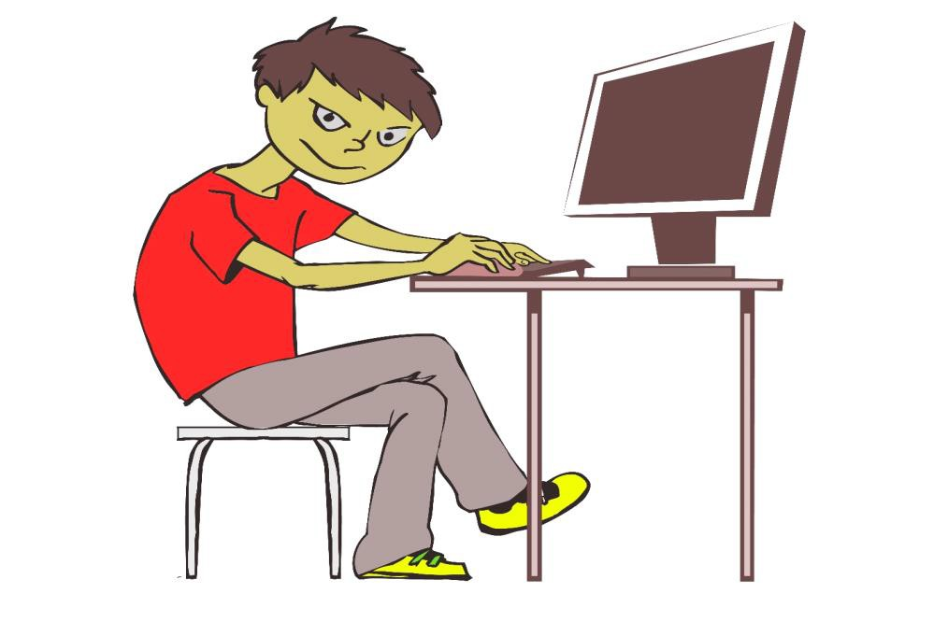

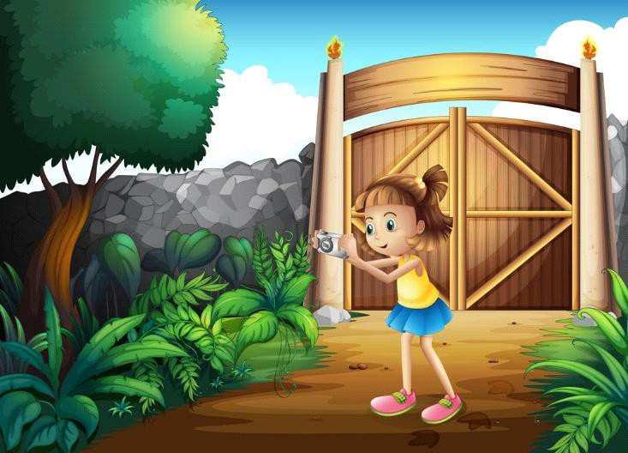

My friend Monica likes to take photos outside and share
them on the Internet. Photos are fun to share on the Internet. Sometimes people put bad photos on the Internet. If we are not sure whether a photo is a bad photo, we should always ask our parents first before sharing it on the Internet. We should also ask our parents before we post anything we think may hurt someone else’s feelings.

We should never share photos of ourselves or others that show us when we are not in our clothes. If someone tries to trick you into showing your private parts on the computer, you need to tell a trusted adult.

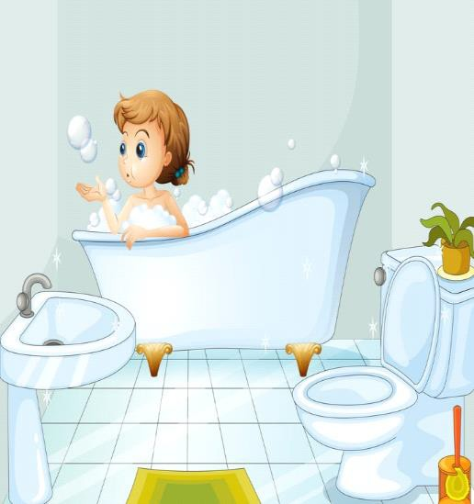

Sometimes adults whom we may or may not know may try to trick us into going somewhere with them. They may say our parents are sick and they need to take us home. They also may ask us whether we want to play with their puppy or kitty.

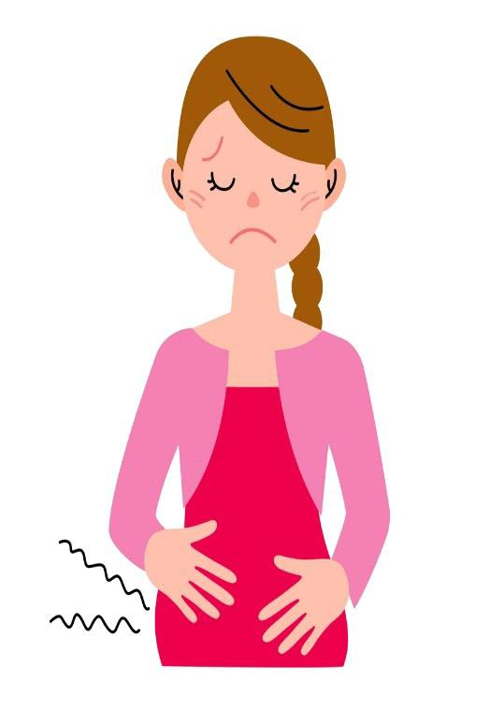

There may be times that adults will try to trick us into riding home in their cars. We should never get in anyone’s car without asking a trusted adult first. A trusted adult can be our teachers, parents, or police officers,

Our parents may ask someone to come and pick us up if they are busy. We should have a secret password that we choose on with our parents. A good password may be our favorite color. If the person who is picking us up does not know the secret password, we should not go with them. Say no, and ask a trusted adult before going anywhere with anyone in a car.

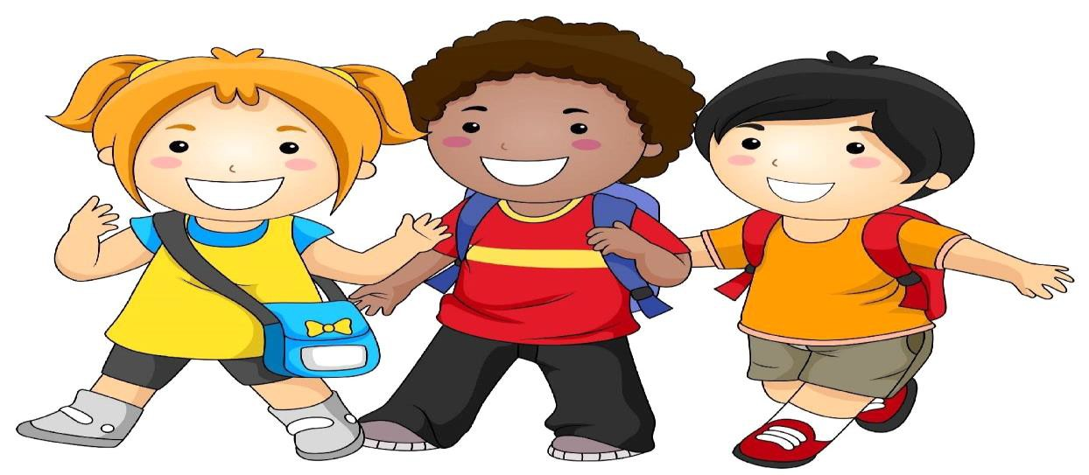

My mom and dad always remind me that I should never play alone. To be safe outside, we need to play with a friend. If we see a friend walking home alone from school, we should ask that friend to walk with us.

We should never take candy or gifts without our parents’ permission. We should get away from anything that makes us feel scared. We can trust our feelings. When we are scared of someone, we can tell people we know about it. Telling other people about it can help other children be safe. People we can tell are our parents, a police officer, a trusted adult, a mail carrier, a store clerk, a doctor, people behind desks, and people who are wearing name tags.

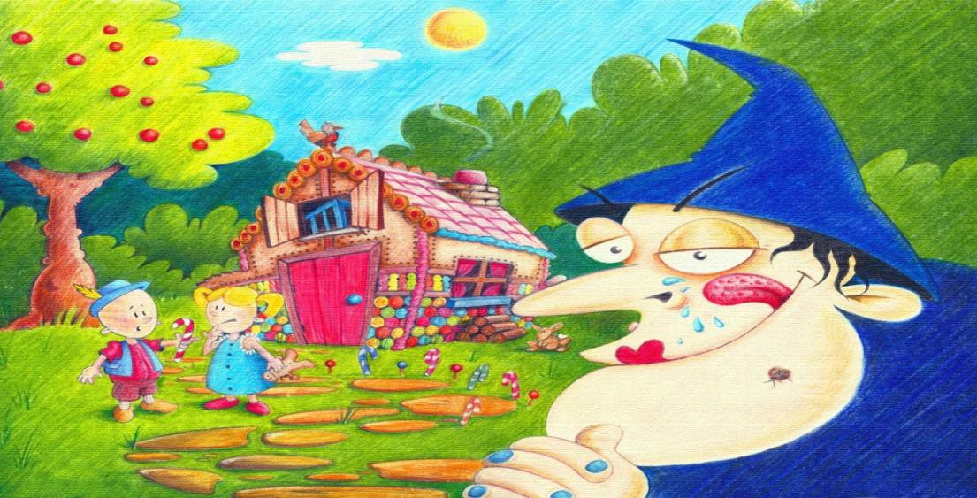

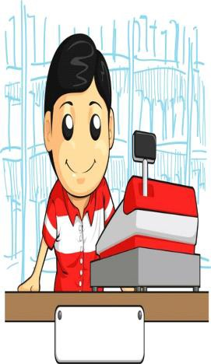
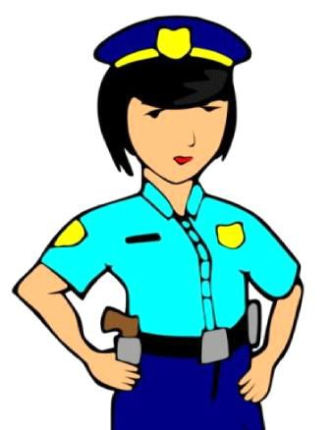

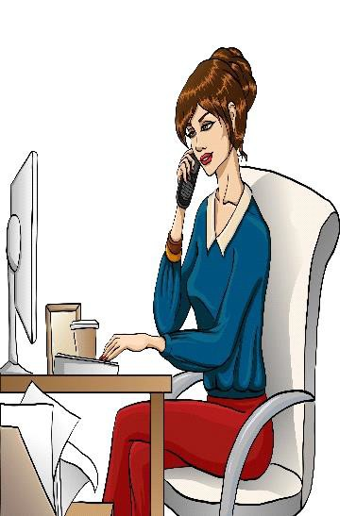

My mom told me that children need to play safely. She said, “All children have a right to be safe.” Children should not be hit, pinched, or kicked. If someone hits, pinches, or kicks us, we should tell our teacher, a police officer, our parents, or a trusted adult. Telling on someone who is mean to us is not tattling. Telling is an important way to stop someone from getting hurt.

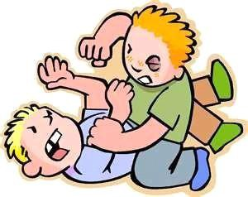

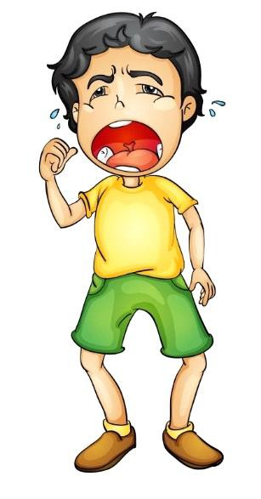.

My friend Adam went to the store with his dad. Adam told me someone he did not know tried to pick him up and carry him away. Adam stomped, jumped, screamed, and ran away. He found his dad, and then he was safe. It is okay to scream when someone we don’t know trying to take us away. To be safe in the store, we must stay close to our parents the whole time we are there.

We need to stay safe so that we don’t get hurt. We can tell our teachers, a police officer, our parents, or a trusted adult when someone touches our private parts or hits us. We need to keep telling until we are safe. If someone we don’t know tries to make us go with them, we should run away and tell. We should never go with someone we do not know. We should not walk alone. Always walk with a friend.

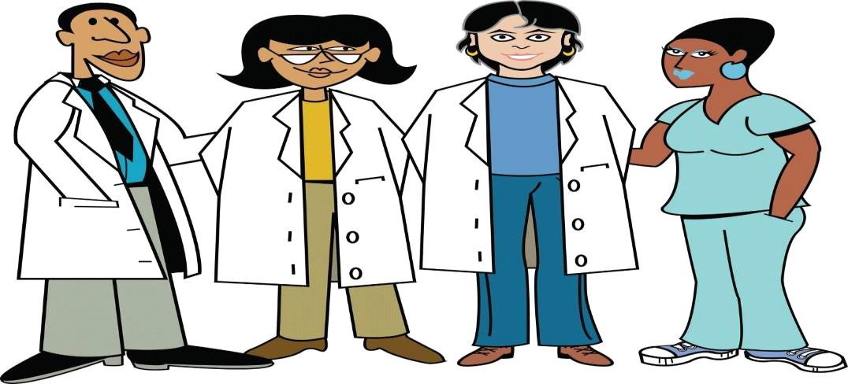

Warning Signs of Sexual Abuse in Children:

- Exhibiting trouble walking or sitting

- Displaying knowledge or interest in sexual acts inappropriate to his or her age, or even seductive behavior

- Making strong efforts to avoid a specific person, without an obvious reason

- Not wanting to change clothes in front of others or avoiding physical activities

- Contracting a sexually transmitted infection (STI ) or becomes pregnant, especially under the age of 14

- Running away from home

Warning Signs of Physical Abuse in Children:

- Frequently having injuries or unexplained bruises, welts, or cuts

- Always being watchful and “on alert” as if waiting for something bad to happen

- Having injuries that appear to have a pattern, such as marks from a hand or a belt
- Shying away from being touched, flinches at sudden movements, or being afraid to go home
- Wearing unusual clothes to cover up injuries, such as long sleeve shirts on hot days

Warning Signs of Neglect in Children:

- Wearing clothes that are ill-fitting, filthy, or inappropriate for the weather

- Having consistently bad Hygiene (not bathed, matted and unwashed hair, noticeable body odor)

- Suffering from untreated illnesses and physical injuries

- Being frequently left unsupervised or alone or allowed to play in unsafe situations and environments

Warning Signs of Emotional Abuse in Children:

- Being excessively withdrawn, fearful, or anxious about doing something wrong

- Showing extremes in behavior (extremely compliant or extremely demanding; extremely passive or extremely aggressive)

- Appearing to be unattached to the parent or care giver

- Acting either inappropriately adult-like (taking care of other children) or inappropriately infantile (rocking, sucking his or her thumb, throwing tantrums)

Let’s Play safe

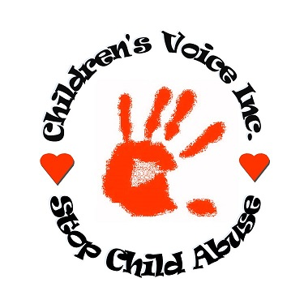

Reporting Child Abuse
When reporting abuse, be as specific as possible. For example, instead of saying, “The parents are not dressing their children right,” say something like, “I saw the child running outside three times this week in subzero weather without a jacket or hat. I saw him shivering and uncomfortable. He seemed to want to come inside.” However, remember that it is not your job to “prove” abuse or neglect. If suspicions are all you have, you should report those as well.

If you are concerned that a child you know may be a victim of abuse, call your local law enforcement agency. You can also find your states child abuse report number at
childrensvoiceinc.org

Book Donated by Children’s Voice Inc.

