Jill Goes Camping
Today is going to be a very exciting day for Jill. Jill is going camping with all her friends. Jill is going to ride the bus with her friends to camp.

When Jill and her friends get to the camp everyone gets their camping stuff and they put it in the camping cabin.

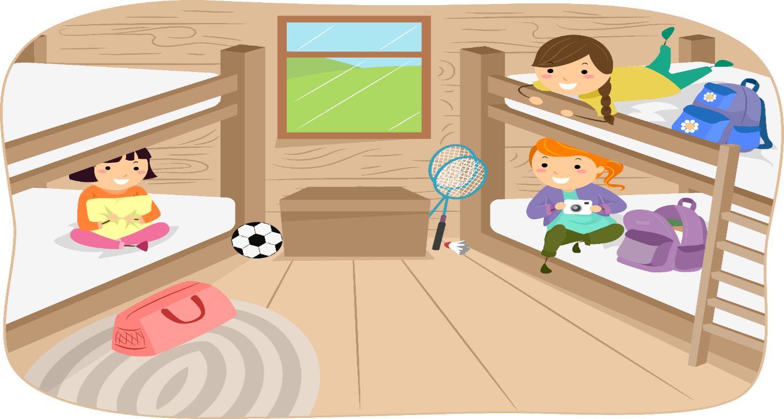
Jill and her friends now meet all the camp councilor’s. There is Mark, Danny, Diego, and Suzy.

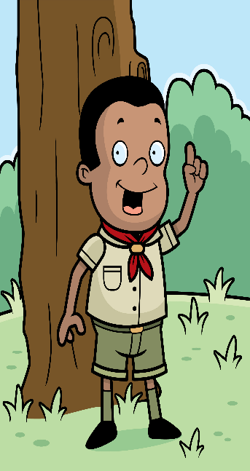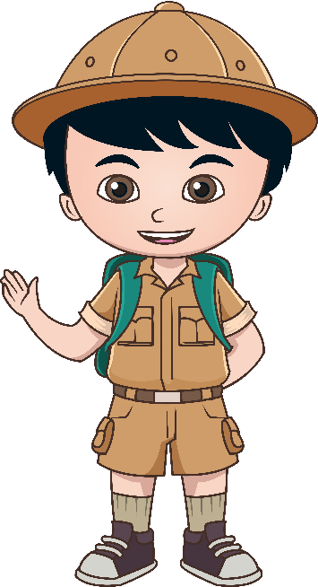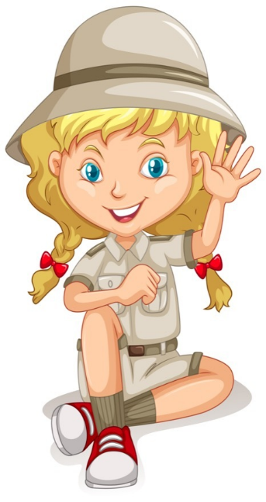

It has been a long day riding the bus and putting the camping equipment away. All of the camp kids and Jill are tired now and need to get some sleep so everyone goes to their cabin to sleep.
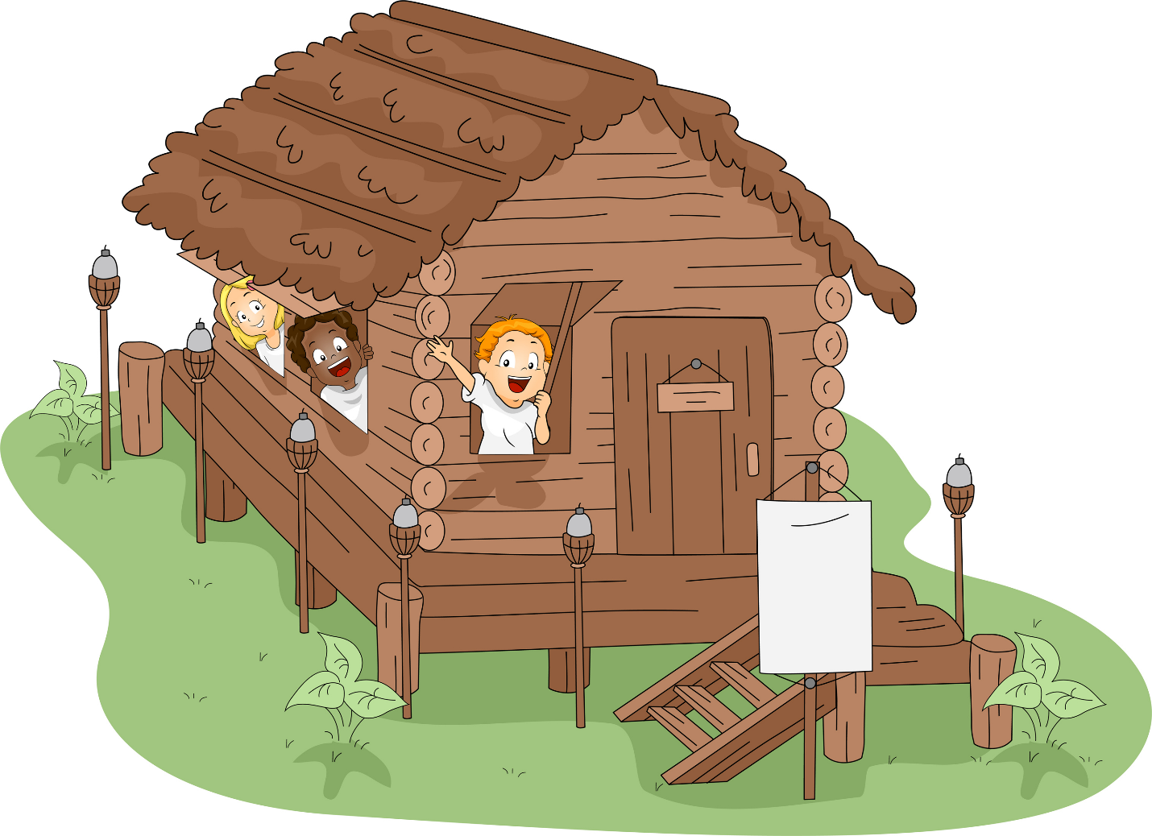

In the morning everyone gets up for breakfast and meets outside to eat.

Today at camp Jill and her friends are going to go swimming. Danny the camp consoler is going to take everyone swimming at the lake.

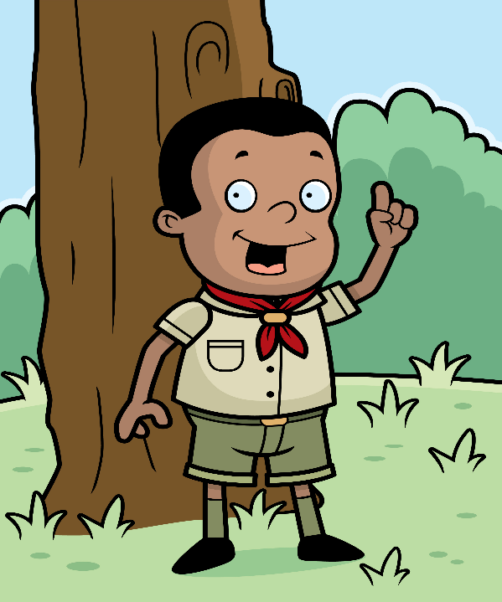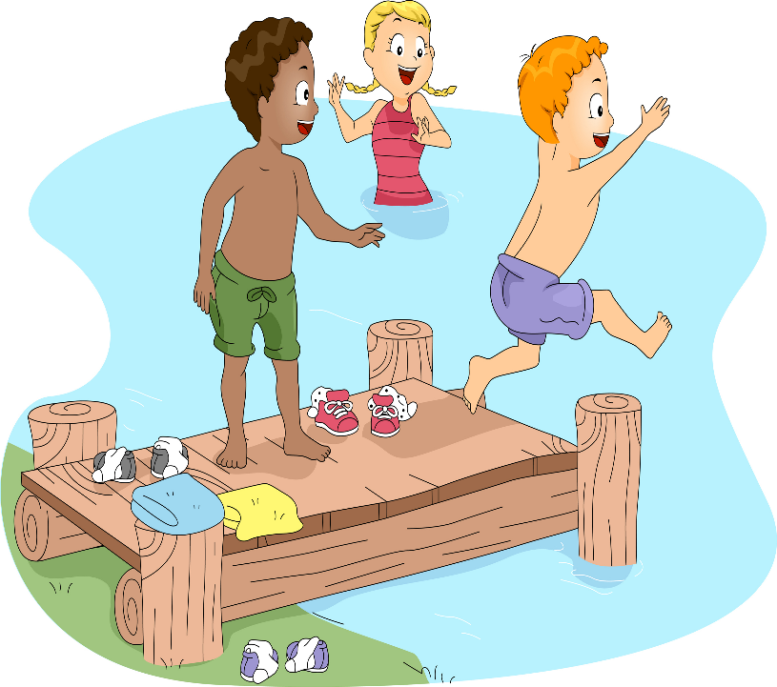

Jill’s friends Mike and Lisa like to draw and make arts and crafts. Mike and Lisa are excited to do arts and crafts the next day at camp.

On Thursday Diego is going to take the camp kids looking for butterfly’s and bugs.

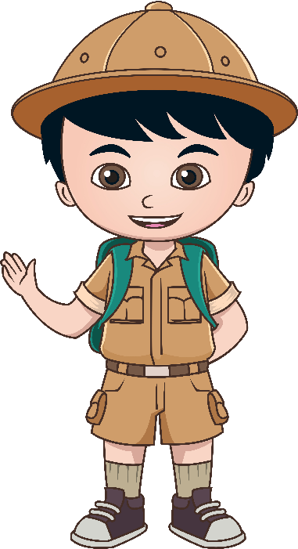

Jill and the camp kids find a lot of nice bugs and butterfly’s. They also find a lot of not so nice bugs.
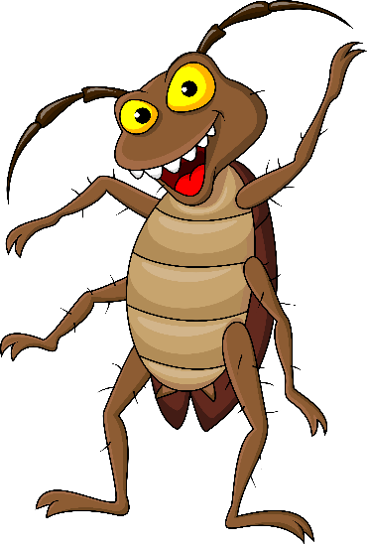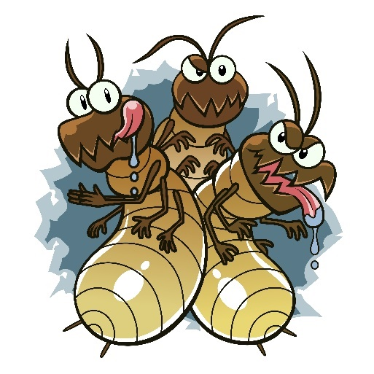
On Friday Mark is going to take Jill and the camp kids hiking in the woods. Mark is also going to help put up the tents. Jill and her friends from camp will be sleeping outside in their tents after they get them up.

Jill and all the camp kids puts up ther tents with the help of Mark the camp consoler. After the tent are put up everyone is proud of their tent.

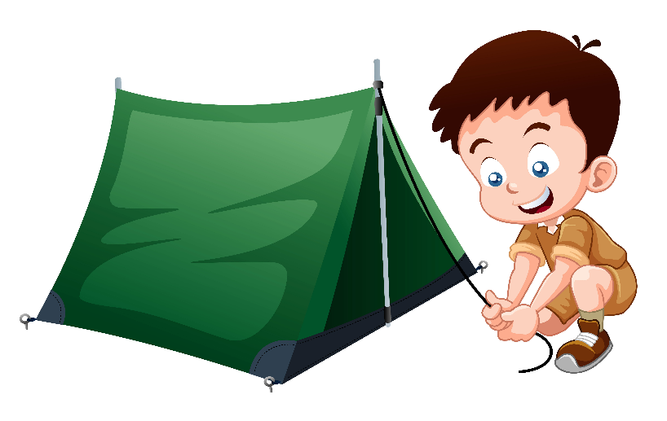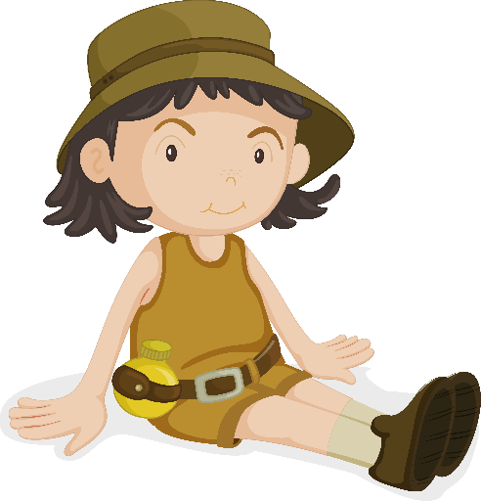
After the tents are up. Mark the camp consoler help the camp kids get wood for a camp fire. Tommy and Coco collect the most wood out of all the kids.

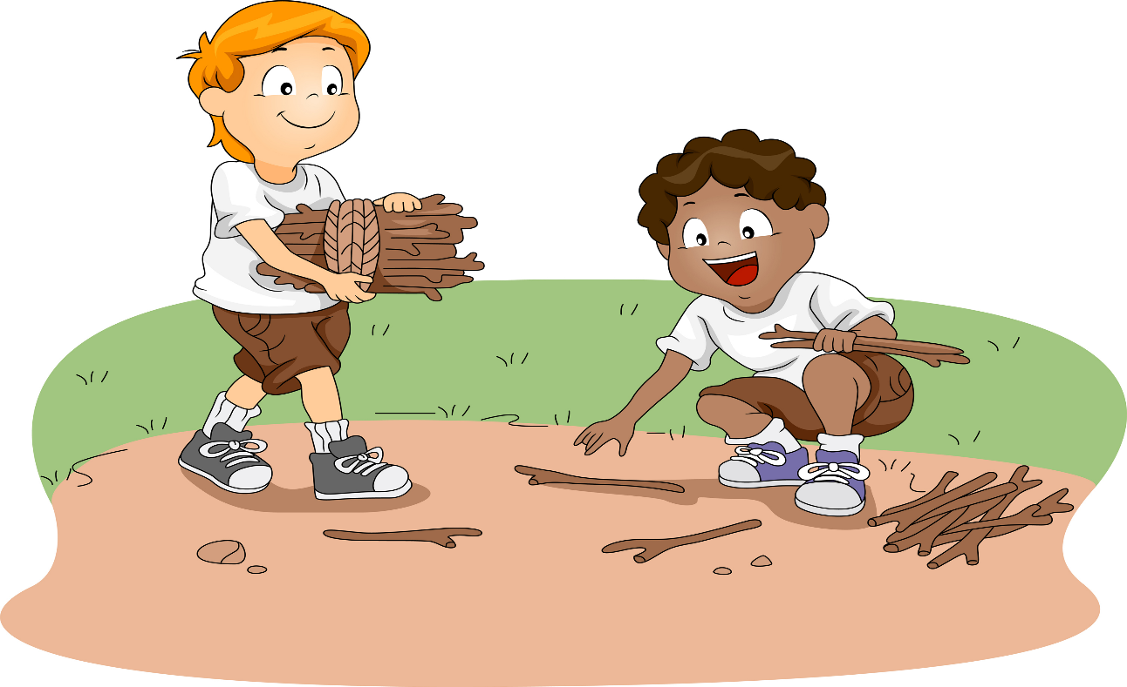

Soon as it gets dark Mark the camp consoler puts out the camp fire. All the camp kids go to their tents to sleep.

Jill is now sleeping restfully in her tent. She is suddenly awoken by a strange man. The strange man touches Jill on her chest and under her swimming suit bottoms. Jill is very scared. The man’s voice sounds like Mark the camp consoler. As the tent door opens Jill see’s that it is Mark the camp consoler.

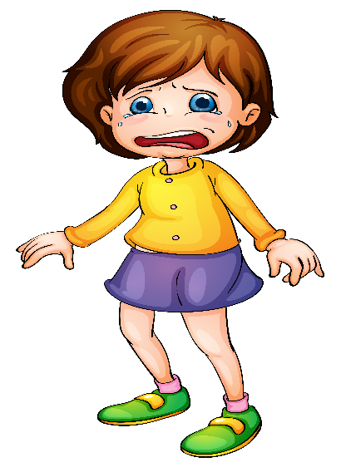

Jill is scared all night long into the morning. Jill does not know what to do so Jill goes and finds her friend John to ask him what she should do. John tells Jill his mom told him he should tell right away is someone touches you and you feel funny or if someone touches you on your private parts.

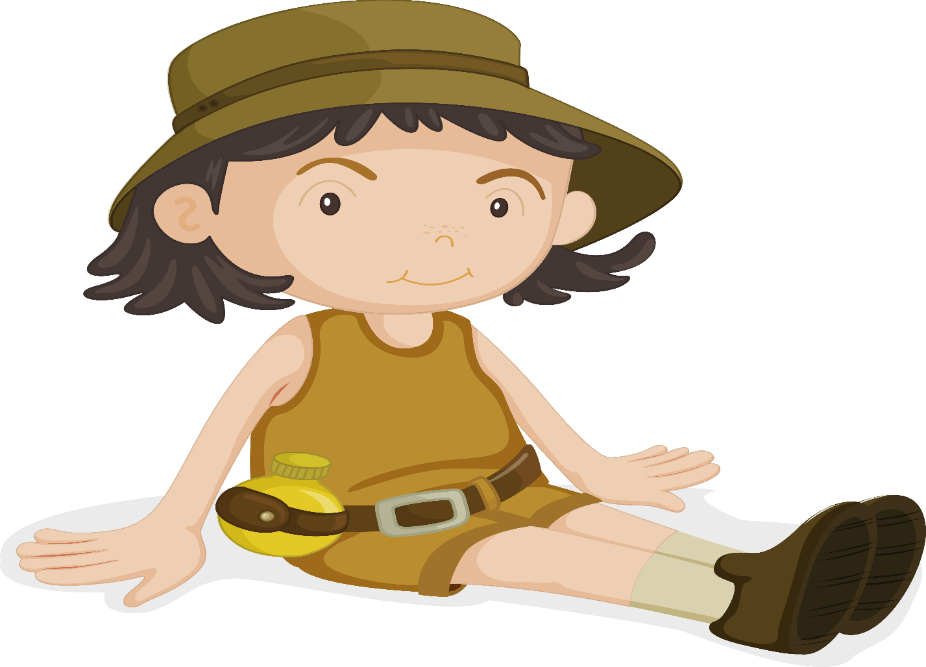

Jill and John decide to go to the camp ground and tell the Nurse Suzy what happened to Jill last night.

Suzy listens to Jill and John and decides she needs to call the police on Mark and report what has happened. Mark is now scared. The police need to make sure all the children are safe so the police take Mark away from the camp ground to question him.

Today is the last day at camp and all the kids are being picked up by their parents. Jill is happy to go home and she is glad all the kids will now be safe from Mark now that she told Suzy the camp consoler what happened.

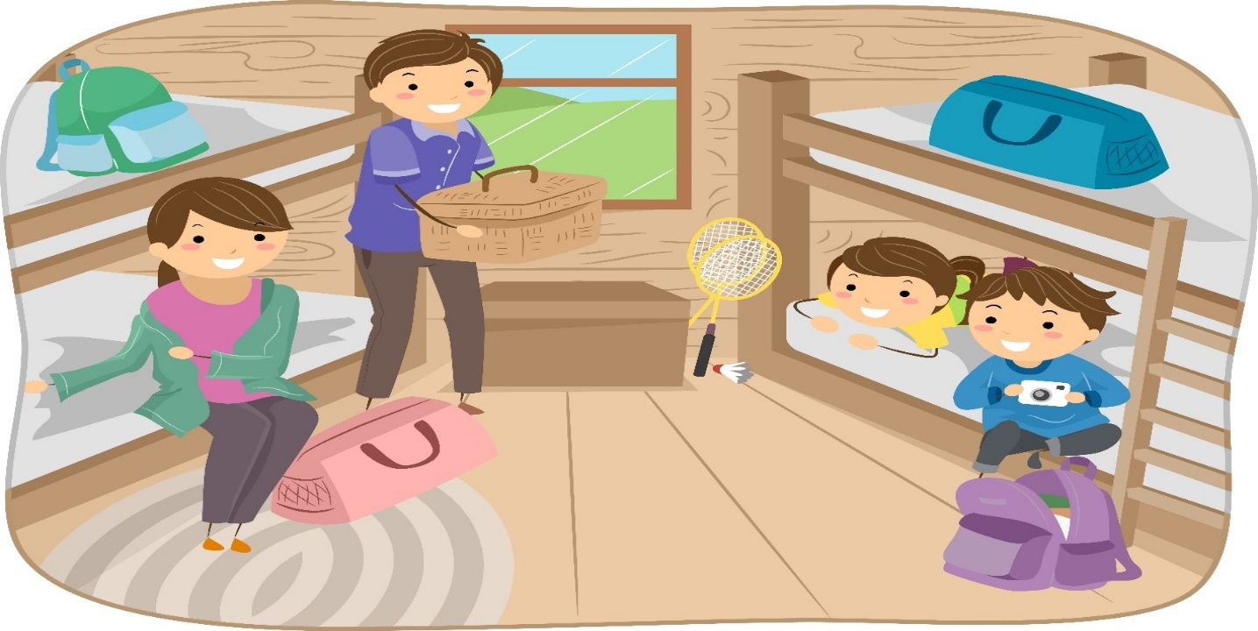

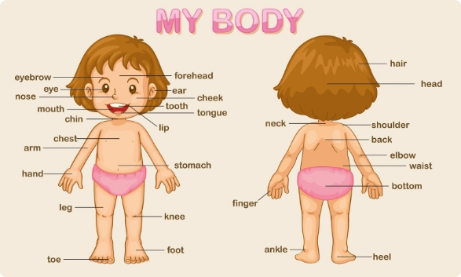
Name all your body parts. Cross off your private parts with a x.

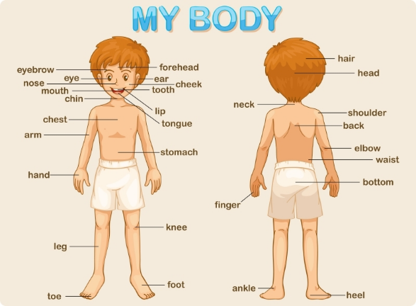
Name all your body parts. Cross off your private parts with a x.

- Cut and paste the camp consoler who took the kids swimming in the first box.
- Cut and paste the camp counselor who called the police on Mark in the second box.

- Cut and paste the strange man that went into Jill’s tent at night in the first box.
- Cut and paste how you would feel if someone touched you in the wrong way in the second box.

- Draw a picture of how you would feel if someone touched you the wrong way.

